IC&IT Assignment
Question bank 3

IITM
Question Bank
BCA Ist Year Semester I
Subject Name: IC & IT
Subject Code: BCA-105

Unit-III
Section-A
- Describe Binary number system?
- What is the significance of 2’s complement in binary arithmetic?
- What do you mean by grey code?
- Define ASCII code?
- Describe EBCDIC coding scheme?
- What do you mean by unit distance code?
- Describe floating point number representation?
- What is meant by base of the number system?
- Describe Excess-3 code?
- What do you understand by BCD code?
Section-B

- What is meant by the base of a number system? Explain its role in positional number system?
- Find the binary, octal and hexadecimal equivalents of the following decimal numbers:
- Explain using an example the additive approach of subtraction?
- Explain briefly how multiplication and division operations are performed using additive approach:
- What is the advantage of using the complementary system to perform the subtraction in digital computer?
- Why was BCD code extended to EBCDIC?
- Represent the 1’s complement and 2’s complement of the following decimal number: a) -46 b) +78
- Write a short note on i) Signed magnitude ii) 1’s complement iii) 2’s complement
- Differentiate between Positional number system and non positional number system?
- Differentiate between Weighted code & non-weighted code?

Section -C

- a)Perform the following:
b) Write short notes on unicodes?
- Write a short note on the following:
- ASCII code
- BCD Code
- Grey codes
- Excess-3 code

- Perform the following:
- What is the value of the base of binary number system, octal number system and hexadecimal number system? Explain in detail.
- Define the term byte? What is the difference between a bit and a byte?
- Convert the following:
- Differentiate between the following:

-x-x-x-x-

Section A
Ques1: Describe binary number system .
Answer: In mathematics and digital electronics, a binary number is a number expressed in a base-2 numeral system or binary numeral system, which uses only two symbols typically zero (0) and one (1).
The base-2 numeral system is a positional notation with a radix of 2 . Each digit is referred to as a bit. Because of its straight forward implementation in digital electronic circuitry using logic gates, the binary system is used by almost all modern computers and computer based devices .

Ques2: What is thesignificance of 2’s compliment in binary arithmetic?
Answer: 2’s complement is simply a system used for representing negative values in binary systems. It’s quite convenient in how it’s setup for a couple of mathematical operations on binary integers.
The way it works is you take the number, invert all of the bits, and add one to the Least Significant Bit. While not necessarily obvious, this makes it so all numbers leading with a zero are positive and all numbers leading with a one are negative. 0000 is 0, 0001 is 1, 1111 is – 1, - 1110 is – 2 and so forth.
The only real significance over any other system is that it’s easy to implement arithmetic units using this scheme.

Ques3: What do you mean by gray code?
Answer: The reflected binary code (RBC), also known just as reflected binary (RB) or Gray code after Frank Gray, is an ordering of the binary numeral system such that two successive values differ in only one bit (binary digit). The reflected binary code was originally designed to prevent spurious output from electromechanical switches. Today, Gray codes are widely used to facilitate error correction in digital communications such as digital terrestrial television and some cable TV systems.

Ques4: Define ASCII code?
Answer: ASCII is an acronym for American Standard Code for Information Interchange.
It is a code that uses numbers to represent characters. Each letter is assigned a number between 0 and 127. A upper and lower case character are assigned different numbers. For example the character A is assigned the decimal number 65, while a is assigned decimal 97 as shown below int the ASCII table.
The ASCII code predates the Internet and has been around since the days of teletypes and mechanical printers. ASCII decimal numbers from 0 to 31 represent control codes that are not used that much these days. However if you are playing with communications protocols you will see these control codes in use. The ASCII Control Codes table explains what each of these control codes are.

Ques5: Describe EBCDIC coding scheme?
Answer:EBCDIC (Extended Binary Coded Decimal Interchange Code ) (pronounced either “ehb-suh-dik” or “ehb-kuh-dik”) is a binary code for alphabetic and numeric characters that IBM developed for its larger operating systems. It is the code for text files that is used in IBM’s OS/390 operating system for its S/390 servers and that thousands of corporations use for their legacy applications and databases. In an EBCDIC file, each alphabetic or numeric character is represented with an 8-bit binary number (a string of eight 0’s or 1’s). 256possible characters (letters of the alphabet, numerals, and special characters) are defined.
Ques6: What do you mean by unit distance code?
Answer: An unweighted code that changes at only one digit position when going from one number to the next in a consecutive sequence of numbers. Note 1: Use of one of the many unit-distance codes can minimize errors at symbol transition points when converting analog quantities into digital quantities. Note 2: An example of a unit-distance code is the Gray code.
Ques7: Describe floating point number representation?
Answer:Floating-point arithmetic (FP) is arithmetic using formulaic representation of real numbers as an approximation so as to support a trade-off between range and precision. For this reason, floating-point computation is often found in systems which include very small and very large real numbers, which require fast processing times. A number is, in general, represented approximately to a fixed number of significant digits (the significand) and scaled using an exponent in some fixed base; the base for the scaling is normally two, ten, or sixteen. A number that can be represented exactly is of the following form:

Ques8: What is meant by base of the number system?
Answer: In mathematical numeral systems, the radix or base is the number of unique digits, including the digit zero, used to represent numbers in a positional numeral system. For example, for the decimal system (the most common system in use today) the radix is ten, because it uses the ten digits from 0 through 9.
In any standard positional numeral system, a number is conventionally written as (x)_{y} with x as the string of digits and y as its base, although for base ten the subscript is usually assumed (and omitted, together with the pair of parentheses), as it is the most common way to express value. For example, (100)_{dec} = 100 (in the decimal system) represents the number one hundred, while (100)₂ (in the binary system with base 2) represents the number four.

Ques9: Describe Excess-3 code?
Answer:Excess-3, also called XS3, is a non-weighted code used to express decimal number-s. It is another important binary code. It is particularly significant for arithmetic operations as it overcomes the shortcomings encountered while using the 8421 BCD code to add two decimal digits whose sum exceeds 9. This code is used in some old computers.

Ques10: What do you understand by BCD code?
Answer:BCD stands for Binary Coded Decimal.
It works by assigning decimal values 0 to 9 to a group of 4 bits (=a nibble) (so, not using the other 6 values that the nibble can contain).
So, a byte containing the (BCD encoded) value 0100 1001 stands for 49.
The main advantage of using BCDs is that they have exact precision (no rounding errors) and no real maximum length (you can treat them as very, very long byte sequences), and if you have two or more of those values, it’s as easy to add, subtract and multiply as it is like you were doing it on paper, because you can use the digit’s position for the powers of 10:
49 + 12 = (9 + 2) = 11 + (10 * (4 + 1) = 50) = 61
They are mostly used in finance, where usually a predetermined amount of the right-most digits are reserved for fractions.

-x-x-x-x-
Section B
Ques1: What is meant by the base of a number system? Explain its role in positional number system?

Answer: In mathematical numeral systems, the radix or base is the number of unique digits, including the digit zero, used to represent numbers in a positional numeral system. For example, for the decimal system (the most common system in use today) the radix is ten, because it uses the ten digits from 0 through 9.
A positional (numeral) system is a system for representation of numbers by an ordered set of numerals symbols (called digits) in which the value of a numeralsymbol depends on its position.
Ques2: Find the binary, octal and hexadecimal equivalents of the following decimal numbers:

Answer:
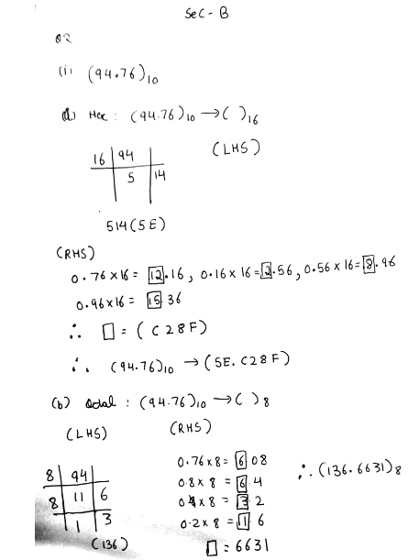
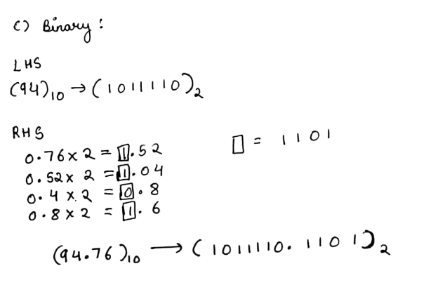

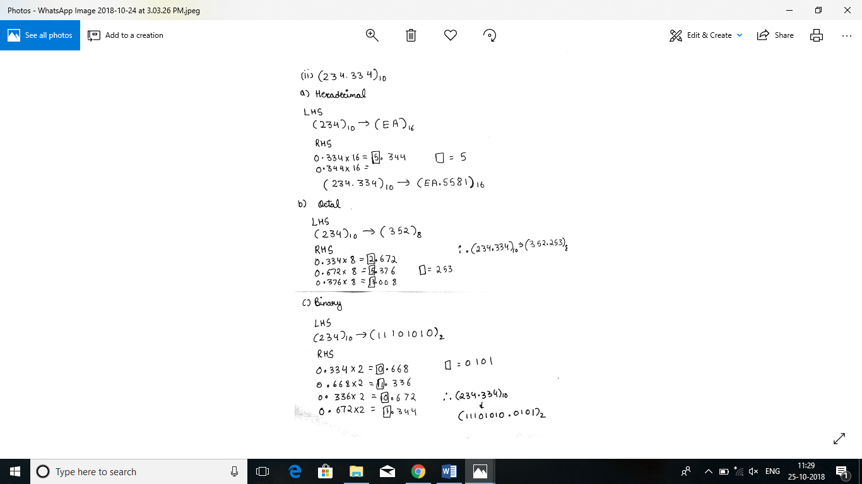
Ques3: Explain using an example the additive approach of subtraction?

Answer: The direct method of subtraction using the-borrow concept seems to be easiest when we perform subtraction with paper and pencil. However when subtraction is implemented by means of digital components, this method is found to be less efficient than the additive method of subtraction. It may sound surprising that even subtraction is performed using an additive method. This method of subtraction by an additive approach is known as complementary subtraction.In order to understand complementary subtraction, it is necessary to know what is meant by the complement of a number. For a number, which has n digits in it, a complement is defined as the difference between the number and the base raised to the nthpower minus one.

Ques4: Explain briefly how multiplication and division operations are performed using additive approach:

Answer: Most modern computers perform multiplication (and division) by special circuits to do just that. At one time Booth’s algorithm was popular, but it is quite likely that other algorithms have replaced it. By the way, one trick I recall is that division is simply multiplication by the reciprocal, which is surprisingly easy to compute, especially if you consider the bit string representing the number to be a fraction rather than an integer.
Understanding, these algorithms is one of those places where more knowledge of math can help, because what are doing has a lot to do with things mathematical.
Even if the computer wasn’t using a more sophisticated algorithm for multiplying, it would used a shift-and-add version, which is simply the algorithm you learned in school but using bits rather than decimal digits.
(i)
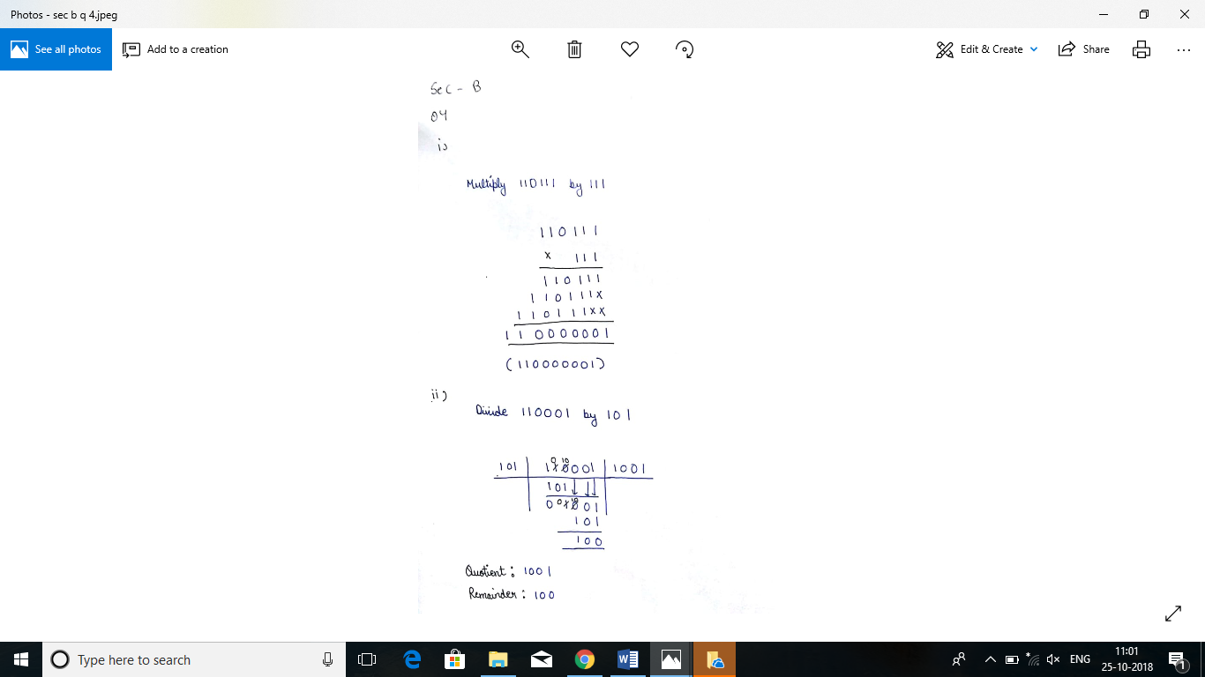
(ii)

Ques5: What is the advantage of using the complementary system to perform the subtraction in digital computer?

Answer:The primary advantage of two's complement over one's complement is that two's complement only has one value for zero. One's complement has a "positive" zero and a "negative" zero.
Next, to add numbers using one's complement you have to first do binary addition, then add in an end-around carry value.
You also asked how the range of values stored are affected. Consider an eight-bit integer value, the following are your minimum and maximum values:
Notation Min Max
========== ==== ====
Unsigned: 0 255
One's Comp: -127 +127
Two's Comp: -128 +127

(i)
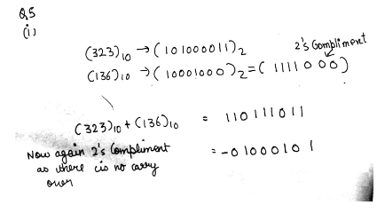

Ques6: Why was BCD code extended to EBCDIC?

Answer: The major problem with BCD code is that only 64 (2 to the power 6) different charactor can be represented in it
This is not sufficient for providing decimal numbers (10), lower case letters (26), and large number of other special characters (28+)

And EBCDIC was obsoleted by ASCII because EBCDIC did not use continuous coding (all the letters of the alphabet in increasing binary values), and because IBM made it difficult for others to use.

Ques7: Represent the 1’s complement and 2’s complement of the following decimal number:
a) -46 b) +78

Answer:
(a)
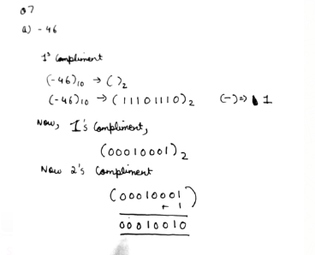

(b)
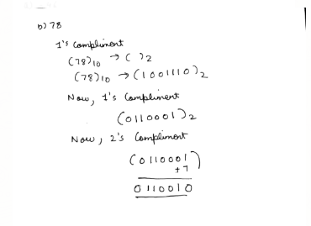
Ques8: Write a short note on i) Signed magnitude ii) 1’s complement iii) 2’s complement

Answer: (i) Signed magnitude :- Negative numbers in any base are represented by prefixing them with a minus ("−") sign. However, in computer hardware, numbers are represented only as sequences of bits, without extra symbols. The four best-known methods of extending the binary numeral system to represent signed numbers are: sign-and-magnitude, ones' complement, two's complement, and offset binary. Some of the alternative methods use implicit instead of explicit signs, such as negative binary, using the base −2. Corresponding methods can be devised for other bases, whether positive, negative, fractional, or other elaborations on such themes.
This representation is also called "sign–magnitude" or "sign and magnitude" representation. In this approach, a number's sign is represented with a sign bit.

(ii) 1’s Complement:- The ones' complement of a binary number is defined as the value obtained by inverting all the bits in the binary representation of the number (swapping 0s for 1s and vice versa). The ones' complement of the number then behaves like the negative of the original number in some arithmetic operations. To within a constant (of −1), the ones' complement behaves like the negative of the original number with binary addition. However, unlike two's complement, these numbers have not seen widespread use because of issues such as the offset of −1, that negating zero results in a distinct negative zero bit pattern, less simplicity with arithmetic borrowing, etc.
A ones' complement system or ones' complement arithmetic is a system in which negative numbers are represented by the inverse of the binary representations of their corresponding positive numbers.

(iii) 2’s Complement :- Two's complement is a mathematical operation on binary numbers, best known for its role in computing as a method of signed number representation. For this reason, it is the most important example of a radix complement.
The two's complement of an N-bit number is defined as its complement with respect to 2^{N}. For instance, for the three-bit number 010, the two's complement is 110, because 010 + 110 = 1000.

Two's complement is the most common method of representing signed integers on computers.^{[1]} In this scheme, if the binary number 010₂ encodes the signed integer 2₁₀, then its two's complement, 110₂, encodes the inverse: -2₁₀. In other words, to reverse the sign of any integer in this scheme, you can take the two's complement of its binary representation.^{[2]} The tables at right illustrate this property.

Ques9: Differentiate between Positional number system and non positional number system?

Amswer:Positional number system:
1. In positional number system, each symbol represents different value depending on the position they occupy in a number.
2. In positional number system, each system has a value that relates to the number directly next to it. The total value of a positional number is the total of the resultant value of all positions.
3. Example: 12 can be 1 x 10 + 2 x 1, 10 + 2 = 12.
Non-Positional number system:
1. In non-positional number system, each symbol represents the same value regardless of its position.
2. In non-positional number system, each symbol represents a number with its own place value.
3. Example: Roman number system where I for 1, II for 2 etc.

Ques10: Differentiate between Weighted code & non-weighted code?

Answer:WEIGHTED CODE - The weighted code are those that obey the position weighting principle, which states that the position of each number represent a specific weight.
In weighted codes, each digit is a assigned a specific weight according to its position.

NON- WEIGHTED CODE - The Non - Weighted Code are not positionally weighted. In other words, codes that are not assigned with any weight to each digit position.
-x-x-x-x-
Section -C

Ques1: a)Perform the following:
b) Write short notes on unicodes?
Answer: (a)
(i)
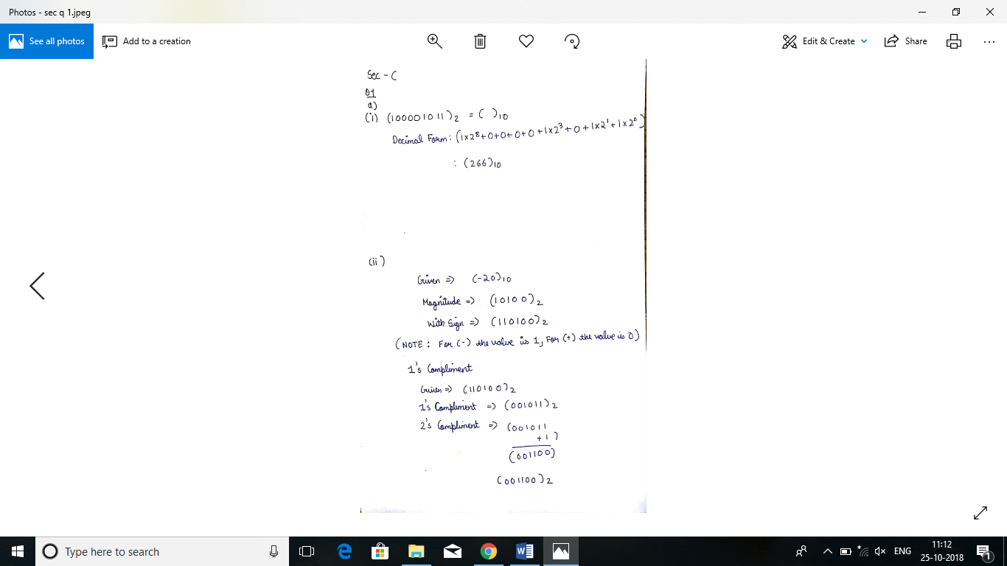

(ii)

(iii)
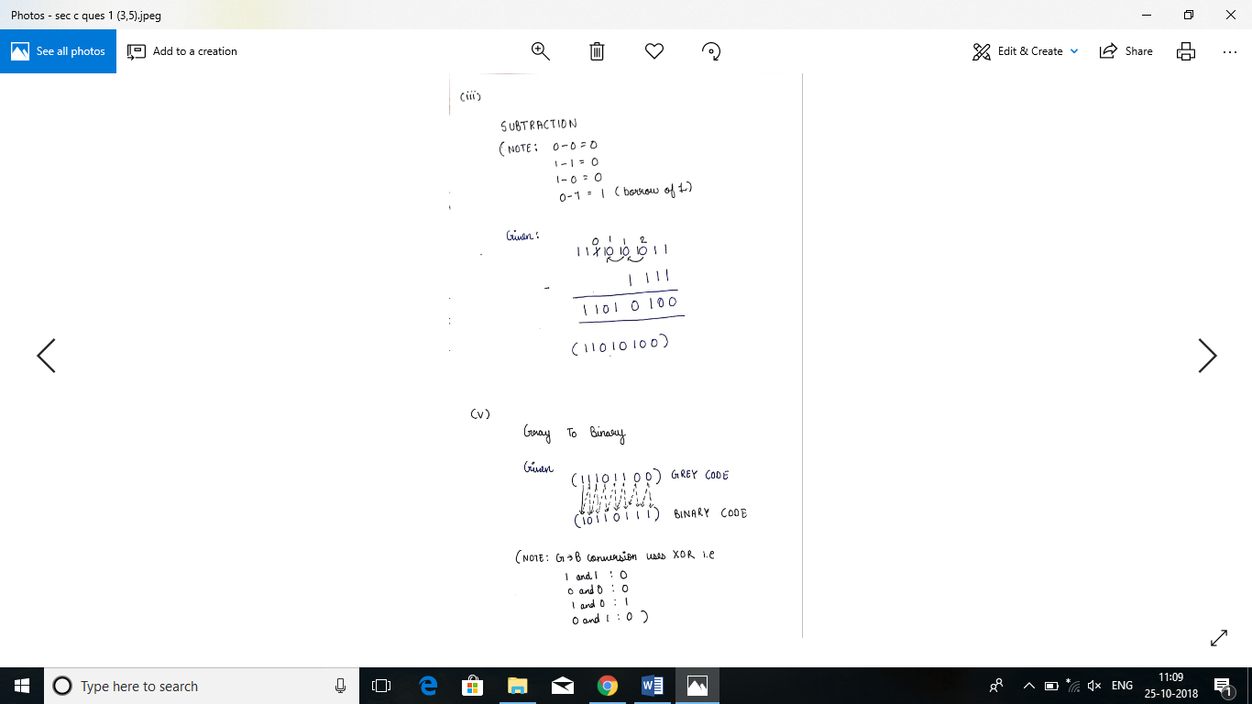

(iv)
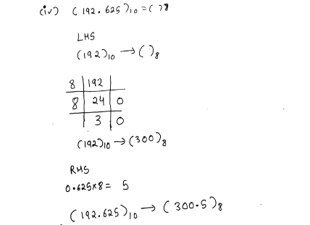

(v)

(b)Unicode is an entirely new idea in setting up binary codes for text or script characters. Officially called the Unicode Worldwide Character Standard, it is a system for "the interchange, processing, and display of the written texts of the diverse languages of the modern world." It also supports many classical and historical texts in a number of languages.
Currently, the Unicode standard contains 34,168 distinct coded characters derived from 24 supported language scripts. These characters cover the principal written languages of the world.
Additional work is underway to add the few modern languages not yet included.
Also see the currently most prevalent script or text codes, ASCII and extended binary-coded decimal interchange code (EBCDIC).
Ques 2: Write a short note on the following:
(I). ASCII code
(II). BCD Code
(III). Grey codes
(IV). Excess-3 code

Answer:
(I)ASCII (American Standard Code for Information Interchange) is the most common format for text files in computers and on the Internet. In an ASCII file, each alphabetic, numeric, or special character is represented with a 7-bit binary number (a string of seven 0s or 1s).UNIX and DOS-based operating systems use ASCII for text files. Windows NT and 2000 uses a newer code, Unicode. IBM's S/390 systems use a proprietary 8-bit code called EBCDIC. Conversion programs allow different operating systems to change a file from one code to another.

(II) In the coding, when numbers, letters or words are represented by a specific group of symbols, it is said that the number, letter or word is being encoded. The group of symbols is called as a code. The digital data is represented, stored and transmitted as group of binary bits. This group is also called as binary code. The binary code is represented by the number as well as alphanumeric letter.

Advantages of Binary Code
Following is the list of advantages that binary code offers.
- Binary codes are suitable for the computer applications.
- Binary codes are suitable for the digital communications.
- Binary codes make the analysis and designing of digital circuits if we use the binary codes.
- Since only 0 & 1 are being used, implementation becomes easy.

(III)Gray code. The reflected binary code(RBC), also known just as reflected binary (RB) or Gray code after Frank Gray, is an ordering of the binary numeral system such that two successive values differ in only one bit (binary digit). The reflected binary code, also known just as reflected binary or Gray code after Frank Gray, is an ordering of the binary numeral system such that two successive values differ in only one bit. The reflected binary code was originally designed to prevent spurious output from electromechanical switches.

(IV) Excess-3, 3-excess or 10-excess-3binary code (often abbreviated as XS-3, 3XS or X3) or Stibitz code (after George Stibitz, who built a relay-based adding machine in 1937) is a self-complementary binary-coded decimal (BCD) code and numeral system. The primary advantage of excess-3 coding over non-biased coding is that a decimal number can be nines' complemented[1] (for subtraction) as easily as a binary number can be ones' complemented: just by inverting all bits. Also, when the sum of two excess-3 digits is greater than 9, the carry bit of a 4-bit adder will be set high. This works because, after adding two digits, an "excess" value of 6 results in the sum. Because a 4-bit integer can only hold values 0 to 15, an excess of 6 means that any sum over 9 will overflow (produce a carry out).
Another advantage is that the codes 0000 and 1111 are not used for any digit. A fault in a memory or basic transmission line may result in these codes. It is also more difficult to write the zero pattern to magnetic media.
Ques 3: Perform the following:

Answer:
(i)
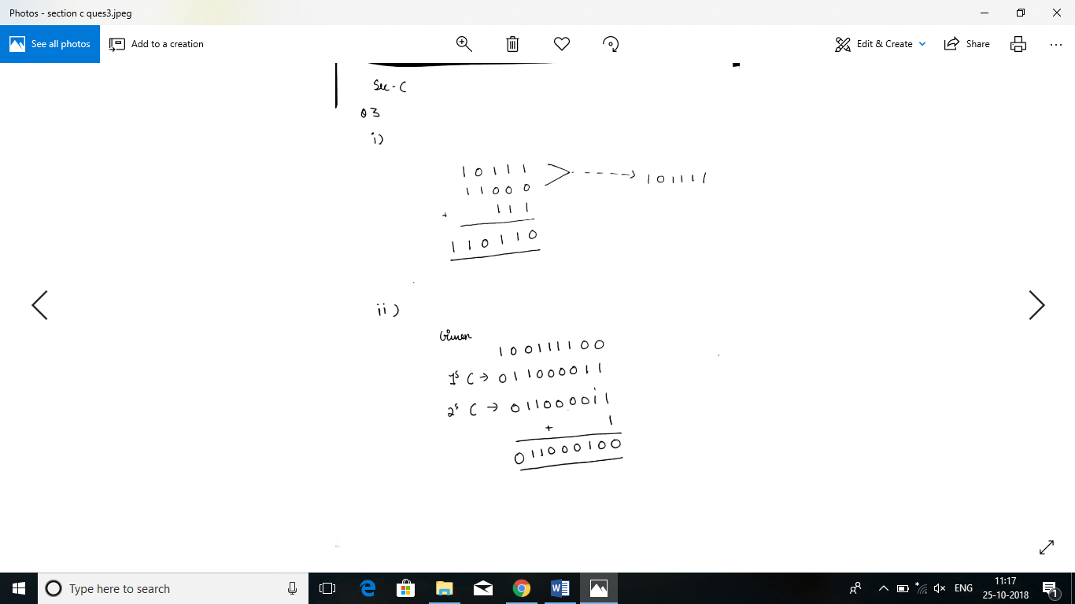

(ii)
(iii)
Ques 4: What is the value of the base of binary number system, octal number system and hexadecimal number system? Explain in detail.

Answer:The Octal Numbering System is very similar in principle to the previous hexadecimal numbering system except that in Octal, a binary number is divided up into groups of only 3 bits, with each group or set of bits having a distinct value of between 000 (0) and 111 ( 4+2+1 = 7 ).
Octal numbers therefore have a range of just “8” digits, (0, 1, 2, 3, 4, 5, 6, 7) making them a Base-8 numbering system and therefore, q is equal to “8”.
Then the main characteristics of an Octal Numbering System is that there are only 8 distinct counting digits from 0 to 7 with each digit having a weight or value of just 8 starting from the least significant bit (LSB). In the earlier days of computing, octal numbers and the octal numbering system was very popular for counting inputs and outputs because as it works in counts of eight, inputs and outputs were in counts of eight, a byte at a time.
As the base of an Octal Numbers system is 8(base-8), which also represents the number of individual numbers used in the system, the subscript 8 is used to identify a number expressed in octal. For example, an octal number is expressed as: 237₈
Just like the hexadecimal system, the “octal number system” provides a convenient way of converting large binary numbers into more compact and smaller groups. However, these days the octal numbering system is used less frequently than the more popular hexadecimal numbering system and has almost disappeared as a digital base number system. As the octal number system uses only eight digits (0 through 7) there are no numbers or letters used above 8, but the conversion from decimal to octal and binary to octal follows the same pattern as we have seen previously for hexadecimal.
To count above 7 in octal we need to add another column and start over again in a similar way to hexadecimal.
0, 1, 2, 3, 4, 5, 6, 7, 10, 11, 12, 13, 14, 15, 16, 17, 20, 21….etc
Again do not get confused, 10 or 20 is NOTten or twenty it is 1 + 0 and 2 + 0 in octal exactly the same as for hexadecimal. The relationship between binary and octal numbers is given below.

Octal Numbers
Decimal Number | 3-bit Binary Number | Octal Number
0 | 000 | 0
1 | 001 | 1
2 | 010 | 2
3 | 011 | 3
4 | 100 | 4
5 | 101 | 5
6 | 110 | 6
7 | 111 | 7
8 | 001 000 | 10 (1+0)
9 | 001 001 | 11 (1+1)
Continuing upwards in groups of three
Then we can see that 1 octal number or digit is equivalent to 3 bits, and with two octal number, 77₈ we can count up to 63 in decimal, with three octal numbers, 777₈ up to 511 in decimal and with four octal numbers, 7777₈ up to 4095 in decimal and so on.

Ques 5: Define the term byte? What is the difference between a bit and a byte?
Answer: Bits and Bytes both measure amounts of data. However, they are typically used in two different contexts.
Bits, kilobits (Kbps), and megabits (Mbps) are most often used to measure data transfer speeds. This may refer to how fast you are downloading a file, or how fast your Internet connection is. For example, if you are downloading a file on cable modem, your download speed might be 240Kbps. This is much faster than a dial-up modem, which maxes out at 56Kbps.
Bytes, on the other hand, are used to measure data storage. For example, a CD holds 700MB (megabytes) of data and a hard drive may hold 250GB (gigabytes). The other important difference is that bytes contain eight bits of data. Therefore, a 240Kbps download is only transferring 30KB of data per second. However, kilobytes per second is not as commonly used as kilobits per second for measuring data transfer speeds. After all, using kilobits per second (Kbps) makes your connection sound eight times faster!
It is important to know that bytes are abbreviated with a capital B, where as bits use a lowercase b. Therefore, Mbps is megabits per second, and MBps is megabytes per second. So 8Mbps is equal to 1MBps.
Ques 6: Convert the following:
Answer:

(a)
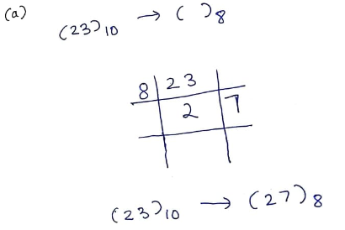

(b)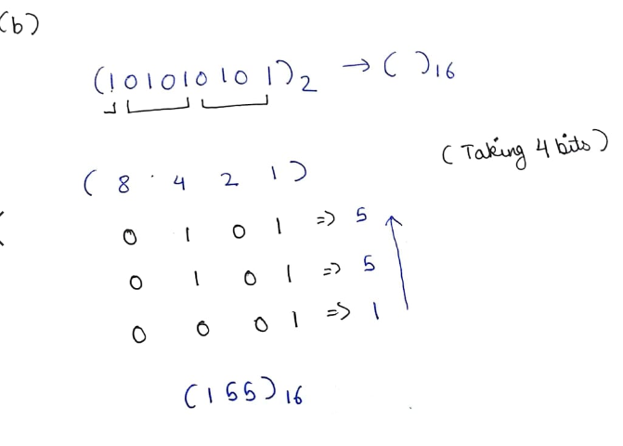

(c)
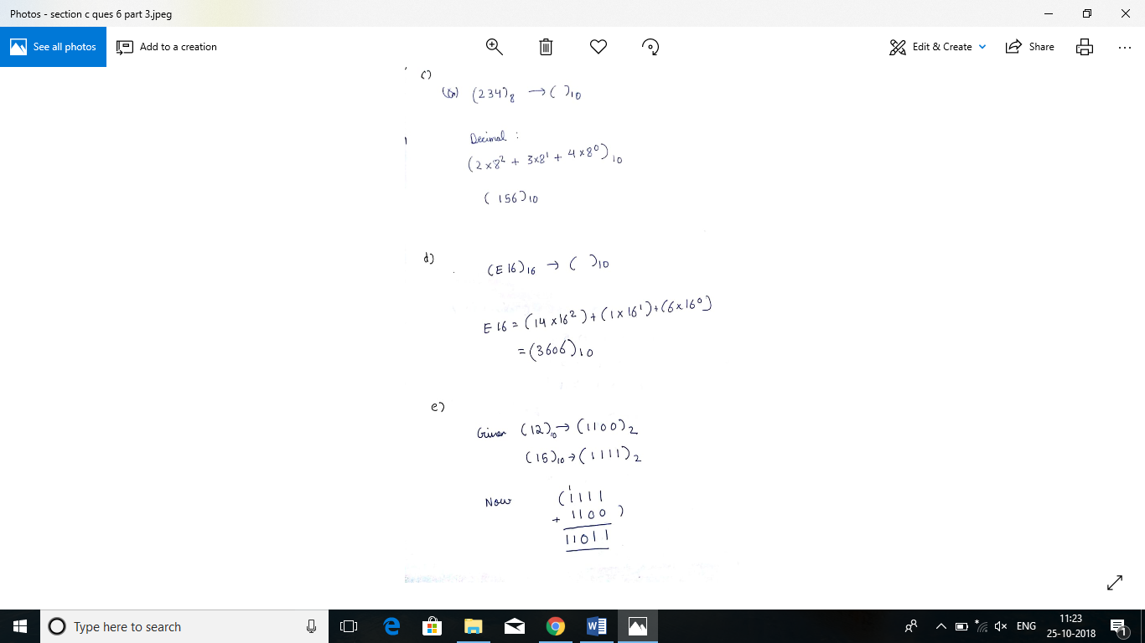

(d)
(e)

Ques 7: Differentiate between the following:

Answer: (a)1’s complement of a binary number is another binary number obtained by toggling all bits in it, i.e., transforming the 0 bit to 1 and the 1 bit to 0.
Examples:
Let numbers be stored using 4 bits

1's complement of 7 (0111) is 8 (1000)
1's complement of 12 (1100) is 3 (0011)
2’s complement of a binary number is 1 added to the 1’s complement of the binary number.
Examples:

Let numbers be stored using 4 bits

2's complement of 7 (0111) is 9 (1001)
2's complement of 12 (1100) is 4 (0100)

These representations are used for signed numbers.
The main difference between 1′ s complement and 2′ s complement is that 1′ s complement has two representations of 0 (zero) – 00000000, which is positive zero (+0) and 11111111, which is negative zero (-0); whereas in 2′ s complement, there is only one representation for zero – 00000000 (+0) because if we add 1 to 11111111 (-1), we get 00000000 (+0) which is the same as positive zero. This is the reason why 2′ s complement is generally used.
Another difference is that while adding numbers using 1′ s complement, we first do binary addition, then add in an end-around carry value. But, 2′ s complement has only one value for zero, and doesn’t require carry values.
(b)In Positional number:

1. In positional number system, each symbol represents different value depending on the position they occupy in a number.
2. In positional number system, each system has a value that relates to the number directly next to it. The total value of a positional number is the total of the resultant value of all positions.
3. Example: 12 can be 1 x 10 + 2 x 1, 10 + 2 = 12.

whereas in Non-Positional number :

1. In non-positional number system, each symbol represents the same value regardless of its position.
2. In non-positional number system, each symbol represents a number with its own place value.
3. Example: Roman number system where I for 1, II for 2 etc.
(c)
Hexadecimal Numbers | Octal Numbers
It uses 16 different symbols or digits for representing numbers. | Octal numbers use only 8 symbols or digits to represent all the numbers. It can have digits from 0 to 7 only.
The radix or base for hexadecimal numbers is 16. | The radix or the base for octal number is 8
Easier to represent and remember large numbers. | Easy to represent using octal number system but difficult to remember large numbers.
Example of Hexadecimal number : FF (Equivalent to Two hundred and fifty five in decimal) | Example of octal number : 377 (Equivalent to Two hundred and fifty five in decimal)

(d) The American Standard Code for Information Interchange and the Extended Binary Coded Decimal Interchange Code are two character encoding schemes; which are more commonly known by their respective acronyms, ASCII and EBCDIC. The main difference between the two is the number of bits that they use to represent each character. EBCDIC uses 8 bits per character while the original ASCII standard only used 7, due to concerns that using 8 bits for characters that can be represented with 7 is much less efficient.
The main consequence of that difference is the number of characters that can be accommodated with each one. EBCDIC can accommodate up to 28 characters for a total of 256 while the 27 of ASCII has a maximum of 128 characters.
Although EBCDIC was very popular, due largely to the popularity of IBM machines at the time, it had several problems that irritated programmers. The first one is how it arranges the letters of the alphabet. In ASCII, all the letters are in consecutive order. Capital letters are grouped together while small letters also have their own group. In EBCDIC, the letters are grouped 9 at a time. This non-intuitive layout comes from the EBCDIC’s punch card origins and is quite difficult for programmers to deal with.
IBM’s hold of the EBCDIC coding has led to many problems when it comes to updates. ASCII and EBCDIC later had updates to increase the number of characters that they can accommodate. ASCII pages had some code points replaced while maintaining most of the other code points. With EBCDIC, the different versions are highly incompatible with each other.
As the encoding needs of computer outgrew both ASCII and EBCDIC, other standard emerged. The most recent is Unicode, which incorporated ASCII. The first 128 characters of Unicode are from ASCII. This lets Unicode open ASCII files without any problems. On the other hand, the EBCDIC encoding is not compatible with Unicode and EBCDIC encoded files would only appear as gibberish.

-X-X-X-X-

